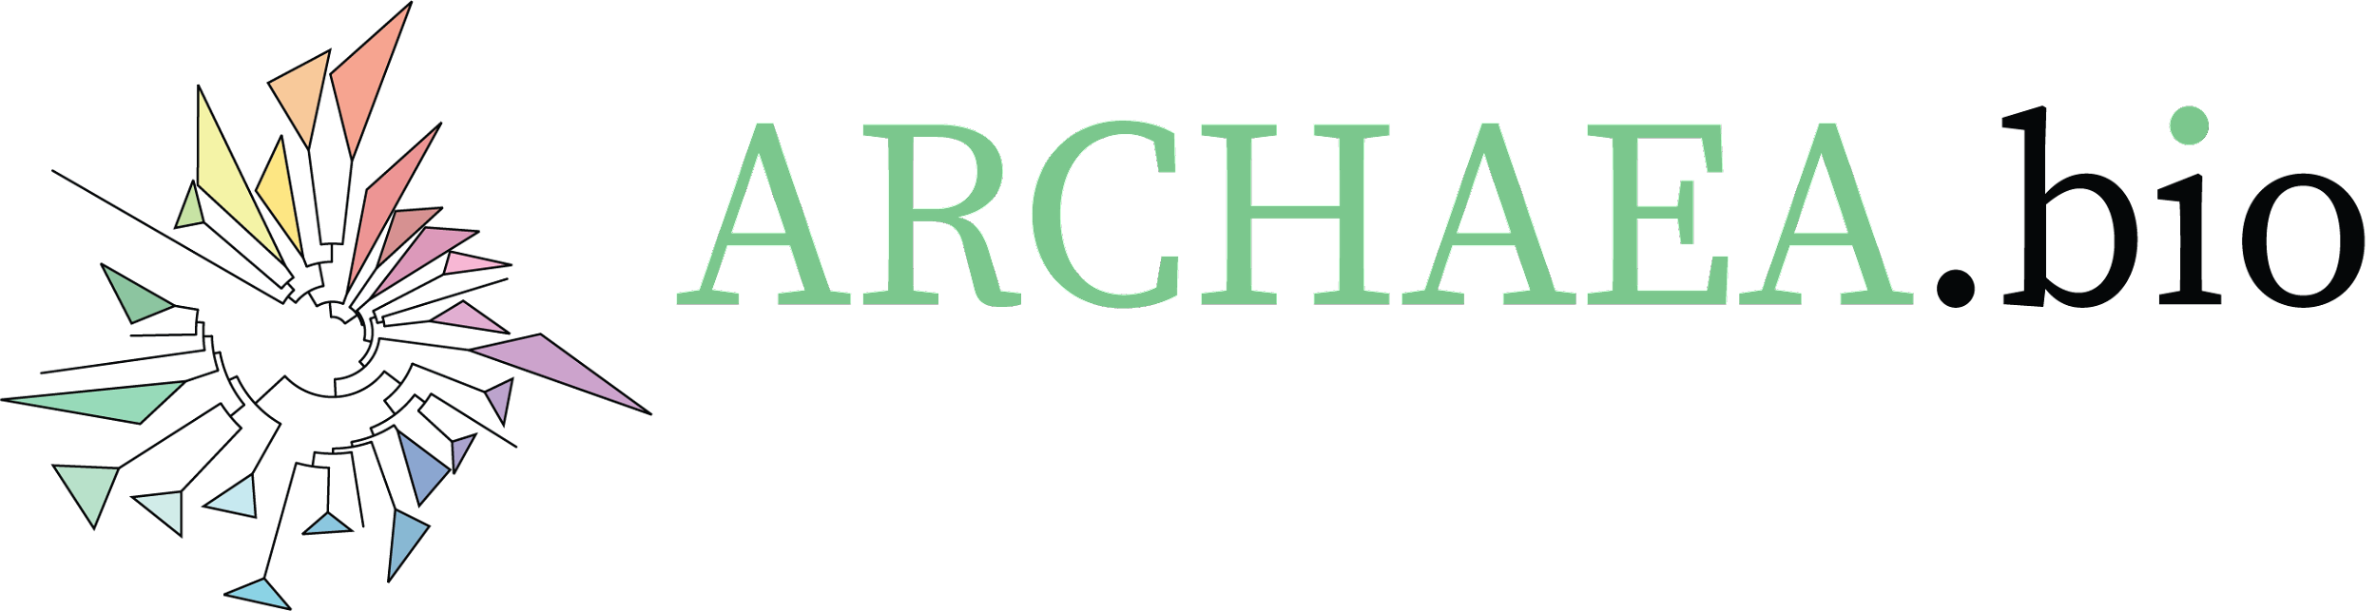
Synchronisation of S. acidocaldarius with Acetic Acid

Corresponding author: Gabriel Tarrason Risa
List of authors: Gabriel Tarrason Risa and Buzz Baum
Group leader: Buzz Baum
Institution: MRC Laboratory for Molecular Cell Biology

Zenodo DOI: [To be added after scientific review by the Society for Archaeal Biology]

Protocol Category: Cell Biology
Model organism(s): Sulfolobus acidocaldarius
Tags: Synchronisation, cell cycle, acetic acid, extremophile

Abstract
This protocol describes how to synchronise a S. acidocaldarius cell culture. The first step is to administer acetic acid to arrest the cells in a G2-like state. Once washed, the culture proceeds synchronously through division and DNA replication for about two cell cycles.

Related publication(s): Tarrason Risa et al, 2020 (this version) and Lundgren et al., 2004 (original version)

Background
S. acidocaldarius belongs to the TACK super phylum (Guy and Ettema, 2011). At the time of writing, these archaea are the closest archaeal relatives of eukaryotes that can be easily grown and studied in a lab. As such, there is considerable interest in understanding their cell biology. However, the field currently lacks the tools to tag and observe S. acidocaldarius proteins in vivo. Synchronisation is therefore key to cell cycle studies in this archaeon. Only one alternative to acetic acid synchronisation currently exists, which uses physical separation based on cell size (Duggin, McCallum, and Bell 2008). Comparing the two, acetic acid synchronisation is simpler and enables higher throughput. However, it is still not known how acetic acid arrests the cell cycle of S. acidocaldarius. Nevertheless, it has become the synchronisation method of choice due to the ease of conducting biochemical and microscopy analyses downstream.

Materials
Product name | Brand / manufacturer | Catalogue number / SKU | Notes
S. acidocaldarius | DSMZ, Leibniz Institute | DSM No.: 639 | Kept at exponential growth for 3 days. OD600 should be between 0.1 and 0.3 when starting the experiment.
Brock medium | Home made |  | See Brock medium protocol
Absolute ethanol | EMPARTA / Merck | 1070172511 | NB fire hazard
100% acetic acid | Sigma-Aldrich / Merck | 695092 | NB Strong smell, use fume hood

Equipment
Equipment name | Brand / manufacturer | Catalogue number / SKU | Notes
Erlenmeyer flasks | Pyrex / Corning | SLW4980-500-6EA | For cells to grow. 20% culture and 80% air
Spectrophotometer cuvettes | Supelco / Merck | C5291-100EA | For OD600 readings
Falcon tubes 15mL | Falcon / Corning | 14-959-49A | Flow cytometry & microscopy
Falcon tubes 50mL | Falcon / Corning | 14-959-53A | Westerns & qPCR & Omics
Screw cap tubes | Merck | AXYSCT150CS | qPCR and westerns
Gilson pipettes and tips | Gilson |  | For liquid handling
Pipette controller and serological pipettes | Fisherbrand / Thermo Fisher Scientific |  | For liquid handling
Shaking incubator at 75°C | Thermotron / Infors HT |  | Must have a shaker capable of maintaining high temperatures

Protocol
- Grow 750mL of S. acidocaldarius (In a 2L+ Erlenmeyer flask) to exponential growth phase (0.1-0.3)
- Collect control samples:
  - Measure OD600
  - Take a 3mL sample and “fix” with 7mL 100% Ethanol (on ice).
  - Take 2 x 25mL samples, spin down at 4,500 rcf for 7 min —> remove liquid —> transfer to a 1mL tube screw cap using 1mL of Brock medium —> spin down at 16,000 rcf for 1 min —> remove liquid and store in a freezer (1 x 25mL for qPCR and 1 x 25mL for western)

- Add Acetic acid to the exponentially growing culture to a final concentration of 3mM (~0.02mL of 100% acetic acid/100mL culture)

- Let cells arrest in acetic acid for 4.5 hrs.
- Record the effect every hour (keeping the culture at 75°C by using a waterbath during):
  - Measure OD600 (should not change)
  - Take a 3mL sample and “fix” with 7mL 100% Ethanol (on ice).
  - Take 2 x 25mL samples, spin down at 4,500 rcf for 7 min —> remove liquid —> transfer to a 1mL tube screw cap using 1mL of Brock medium —> spin down at 16,000 rcf for 1 min —> remove liquid and store in a freezer (1 x 25mL for qPCR and 1 x 25mL for western)

- Wash out the acetic acid
- Take the contents of the arrested cultures and spin down at 4,500 rcf for 5 min
- Resuspend the pellet in fresh and warm Brock media (50mL)
- Spin down at 4,500 rcf for 5 min and resuspend in 50mL fresh and warm Brock
- Repeat this two times to remove any residual acetic acid

Note that step 4 should take around 30 minutes to complete at most

- Re-suspend cells in 50mL fresh and warm Brock media and add them to a 2L Erlenmeyer flask with 650mL fresh and warm Brock media (the culture should have a final OD600 of about 0.08-0.15).
- Every 20 min from time 0 (for at least a total of 200 min for a full cycle):
  - Measure OD600 (should not change)
  - Take a 3mL sample and “fix” with 7mL 100% Ethanol (on ice).
  - Take 2 x 25mL samples, spin down at 4,500 rcf for 7 min —> remove liquid —> transfer to a 1mL tube screw cap using 1mL of Brock medium —> spin down at 16,000 rcf for 1 min —> remove liquid and store in a freezer (1 x 25mL for qPCR and 1 x 25mL for western)

- Store the EtOH fixed samples in the fridge
Note that you need about 1mL of EtOH fixed cells for flow cytometry and about 100uL for immunofluorescence

- Following this protocol, synchronised cells can next be studied by flow cytometry, immunofluorescence microscopy, qPCR, and western blotting, etc.

Data analysis
Typical OD600 readings and flow cytometry profiles from a synchronisation experiment are exemplified in figure 1 and figure 2 below (Tarrason Risa, 2021).

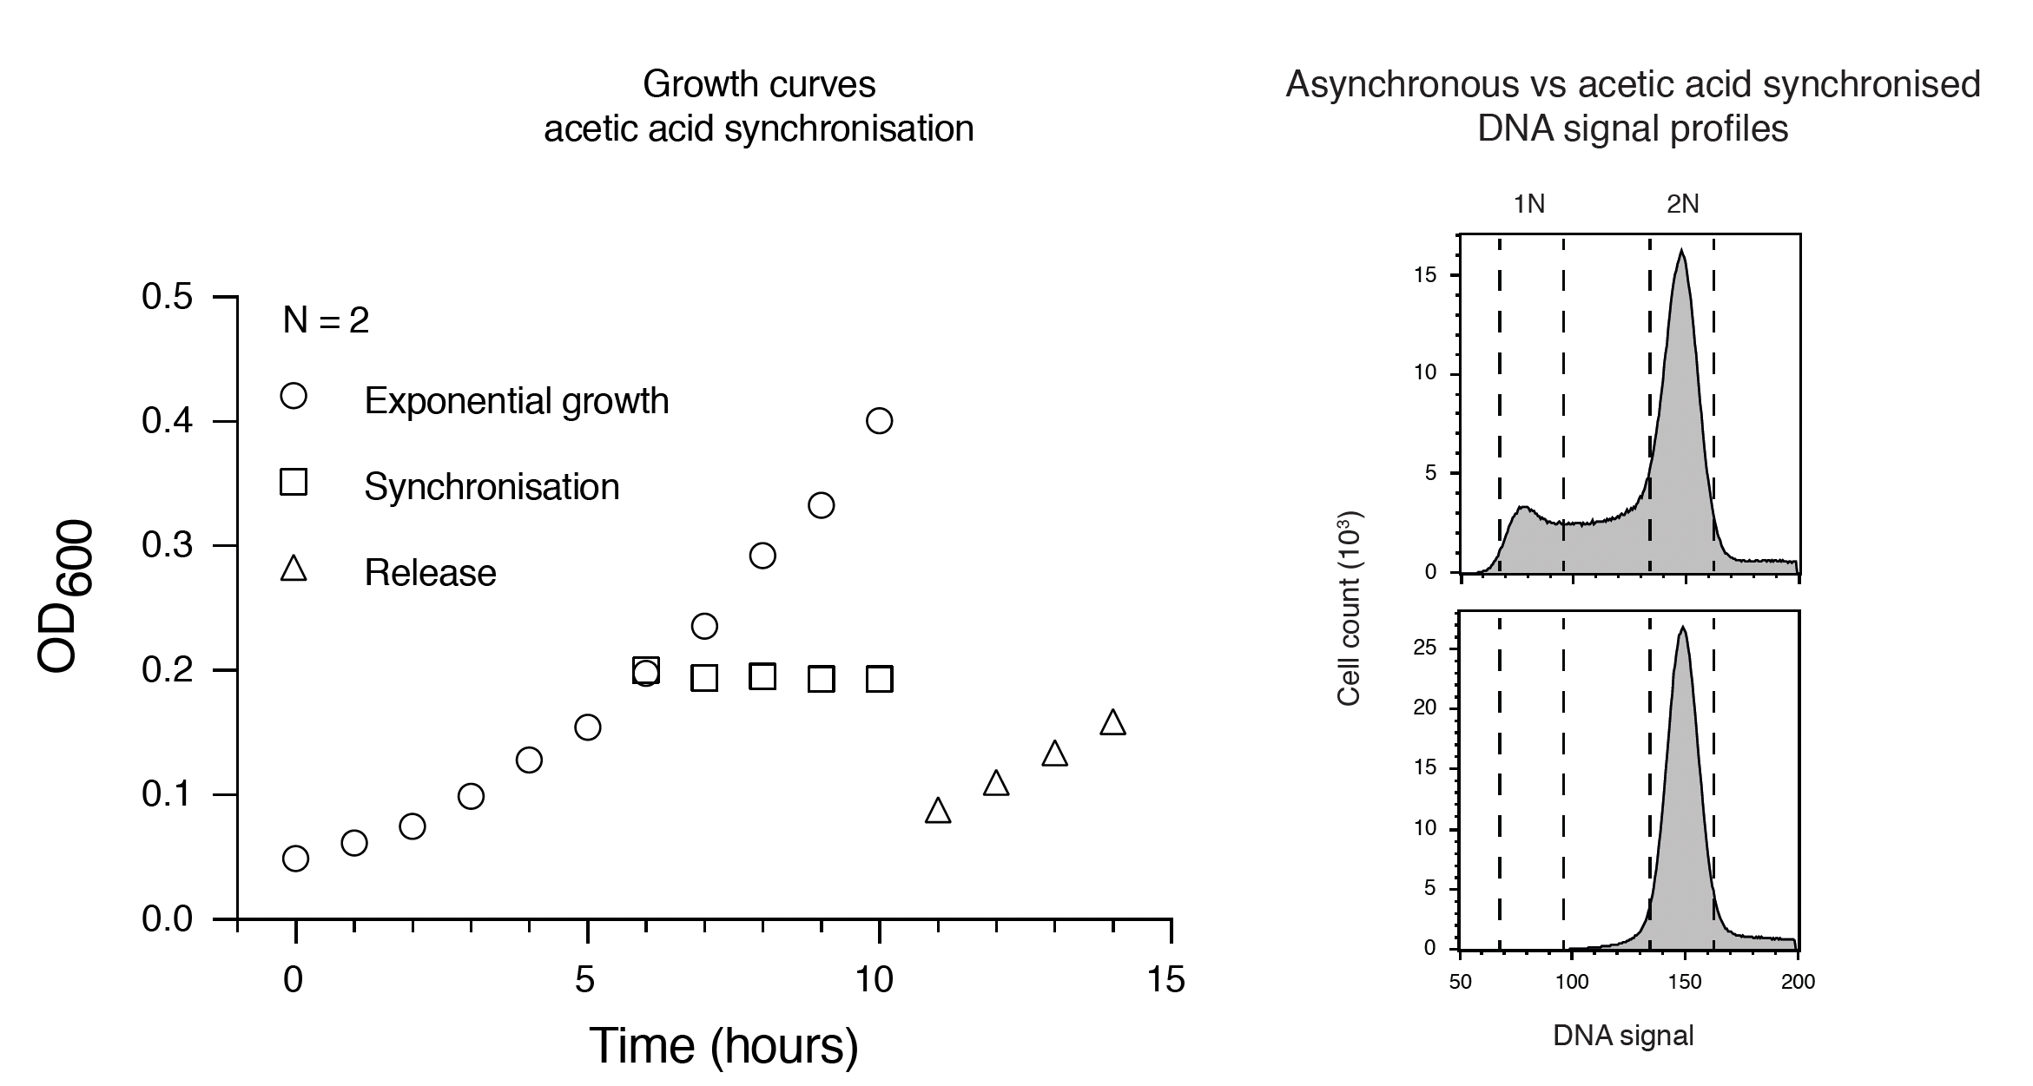
Figure 1: The effect of acetic acid on the growth and cell cycle of S. acidocaldarius. (Left) Growth curve of S. acidocaldarius as detected by a spectrophotometer. Cell growth was arrested upon addition of acetic acid. Washing out the acetic acid allowed the cells to resume growth, albeit more slowly. (Right) Flow cytometry histograms showing the DNA signal profiles of S. acidocaldarius before and 4.5 hours after treatment with acetic acid. After 4.5 hours with acetic acid treatment, no cells were observed with less than 2N DNA signal, indicating completed synchronisation. Representative plots shown, n = 10⁶. Reprinted with permission (Tarrason Risa, 2021).

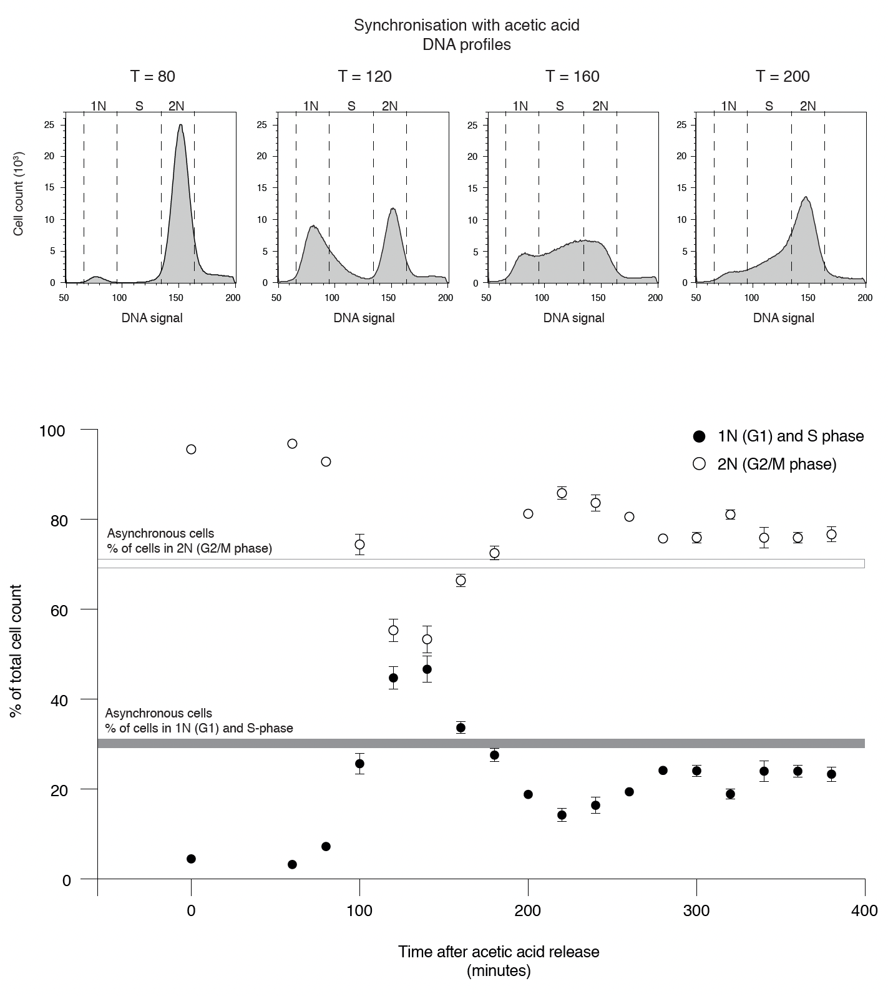
Figure 2: Synchronisation of S. acidocaldarius with acetic acid. (Top) Flow cytometry histograms showing the DNA signal profiles of a synchronised time course experiment with 40-minute intervals from 80 to 200 minutes after release. In this period the cells went from a 2N state (G2 and M-phase), through a 1N state (G1 phase), a between state (S-phase), and return to a majority 2N state (G2). Representative plots shown, n = 106. (Bottom) Quantification of three biological replicates showing the % of cells in a 1N or in between phase (G1 and S-phase) vs a 2N state. The synchrony of cells was nearly lost after one round of division, after which the DNA signal profile was similar to that of an asynchronous culture. N = 3, n = 10⁶. Reprinted with permission Reprinted with permission (Tarrason Risa, 2021).

Additional Notes
Thermal management is critical to the success of the synchronisation. Sample collection and handling should be done at temperatures close to 75°C. If possible, preheating of all equipment including centrifuges is strongly recommended.

Competing interests
The authors declare that they have no conflict of interest.

Acknowledgments
We thank the MRC LMCB at UCL for their support; the flow cytometry STP at the Francis Crick Institute for
assistance, with special thanks to S. Purewal and D. Davis; C. Bertoli for mentorship and advice; J. M. Garcia-
Arcos for help early on in this project; the entire Baum lab for their input; the Albers and Lindås lab for advice and reagents, with special thanks to M. Van Wolferen, S. Albers, Fredrik Hurtig, and Mohea Couturier.

References
- Tarrason Risa G, Hurtig F, Bray S, Hafner AE, Harker-Kirschneck L, Faull P, Davis C, Papatziamou D, Mutavchiev DR, Fan C, Meneguello L, Arashiro Pulschen A, Dey G, Culley S, Kilkenny M, Souza DP, Pellegrini L, de Bruin RAM, Henriques R, Snijders AP, Šarić A, Lindås AC, Robinson NP, Baum B. The proteasome controls ESCRT-III-mediated cell division in an archaeon. Science. 2020 Aug 7;369(6504): eaaz2532. doi: 10.1126/science.aaz 2532. PMID: 32764038; PMCID: PMC7116001.
- Lundgren, Magnus et al. (2004). \Three replication origins in Sulfolobus species: Synchronous initiation of chromosome replication and asynchronous termination". In: Proceedings of the National Academy of Sciences of the United States of America. 101.18, pp. 7046{7051. issn: 0027-8424. doi: 10.1073/pnas.0400656101
- Guy, Lionel and Thijs J.G. Ettema (2011). The archaeal `TACK' superphylum and the origin of eukaryotes". In: Trends in Microbiology 19.12, pp. 580{587. issn: 0966-842X. doi: 10.1016/j.tim.2011.09.002.
- Duggin, Iain G., Simon A. McCallum, and Stephen D. Bell (2008). Chromosome replication dynamics in the archaeon Sulfolobus acidocaldarius". In: Proceedings of the National Academy of Sciences 105.43, pp. 16737{16742. issn: 0027-8424. doi: 10.1073/pnas.0806414105.

- Brock, Thomas D. et al. (1972). \Sulfolobus: A new genus of sulfur-oxidizing bacteria living at low pH and high temperature". In: Archiv für Mikrobiologie 84.1, pp. 54{68. issn: 0003-9276. doi: 10.1007/bf00408082.

- Tarrason Risa, Gabriel; (2021) Archaeal roots of eukaryotic cell cycle control and ESCRT-III mediated cell division. Doctoral thesis (Ph.D), UCL (University College London). URI: https://discovery.ucl.ac.uk/id/eprint/10132115

